**PSG College of Technology, Coimbatore-04**

**Department of Applied mathematics and Computational Sciences**

**20XC28 – Python Programming Lab**

**Problem Sheet – II**

1. The Euclidean distance between points p and q is the length of the line segment connecting them. if p = (*p*1, *p*2,..., *pn*) and q = (*q*1, *q*2,..., *qn*) are two points in Euclidean *n*-space, then the distance from p to q, or from q to p is given by:

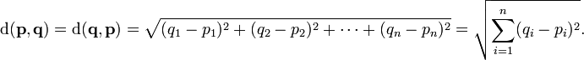

Write a program to compute the distance between the points p(x1,y1) and q(x2,y2) given the coordinates (x1,y1) and (x2,y2).

1. A regular polygon is an *n*-sided polygon in which all sides are of the same length and all angles have the same degree (i.e., the polygon is both equilateral and equiangular). The formula for computing the area of a regular polygon is



Here, sis the length of a side. Write a program that prompts the user to enter the number of sides and their length of a regular polygon and displays its area.



1. A model of worldwide population growth, in billions of people, since 2000 is given by this formula: Population = 6.0 e0.02[Year - 2000] Using this formula, write a C program to estimate the worldwide population in the year 2012.
2. Develop a program that reads a four-digit integer from the user and displays the sum of the digits in the number. For example, if the user enters 3141 then your program should display 3+1+4+1=9.
3. Let s1, s2 and s3 be the lengths of the sides. Let s = (s1 + s2 + s3)/2. Then the area of the triangle can be calculated using the following formula:



Develop a program that reads the lengths of the sides of a triangle from the user and displays its area.

1. Write a program to calculate the x and y coordinates of a point at a distance r from the origin at an angle θ to the x-axis as shown in the following figure.

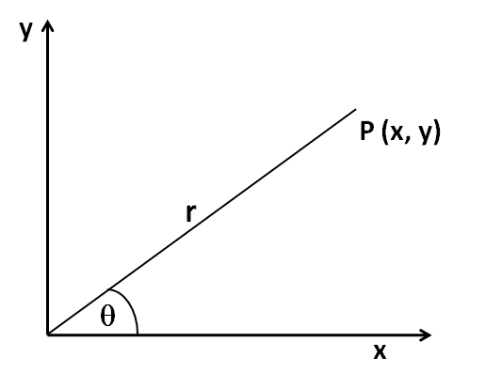

The trigonometric functions are as follows:

x= r cos θ

y= r sin θ

1. A bakery sells loaves of bread for Rs. 75 each. Day old bread is discounted by 60 percent. Write a program that begins by reading the number of loaves of day old bread being purchased from the user. Then your program should display the regular price for the bread, the discount because it is a day old, and the total price. All of the values should be displayed using two decimal places.
2. Write a program to find the simple interest, compound interest and maturity value. Simple interest I is

Description: simple interest formula

The formula to find the maturity value, **S** is given below:

Description: maturity value formula

where

1. **P** is the principal (the amount of money borrowed)
2. **r** is the interest rate (per year or per annum)
3. **t** is the loan duration in years.

The compound interest formula is given below:

Description: compound interest formula

where

1. **A** is the total amount of money (including interest) after **n** years
2. **P** is the principal (the amount money borrowed or invested)
3. **r** is the interest rate (per year or per annum)
4. **n** is the loan or investment duration in years
5. The voltage gain of an amplifier is given by this formula:



Where, f is the frequency in Hz. n is the number of stages in the amplifier. Using this formula, write a C program to determine the value of the voltage gain for a four- stage amplifier operating at a frequency of 120 Hz.

1. Suppose you have a certain amount of money in a savings account that earns compound monthly interest and you want to calculate the amount that you will have after a specific number of months. The formula is



The terms in the formula are as follows:

• F is the future value of the account after the specified time period.

• P is the present value of the account.

• i is the monthly interest rate.

• t is the number of months.

Write a program that prompts the user to enter the account’s present value, monthly interest rate, and number of months that the money will be left in the account. The program should pass these values to a function that returns the future value of the account after the specified number of months. The program should display the account’s future value.

1. Create a program that determines how quickly an object is traveling when it hits the ground. The user will enter the height from which the object is dropped in meters (m).

Because the object is dropped its initial speed is 0 m/s. Assume that the acceleration

due to gravity is 9.8m/s2. You can use the formula



to compute the final speed, *vf* , when the initial speed, *vi* , acceleration, *a*, and distance, *d*, are known.

1. Write a program that generates a random number in the range of 1 through 100 and asks the user to guess what the number is. If the user’s guess is higher than the random number, the program should display “Too high, try again.” If the user’s guess is lower than the random number, the program should display “Too low, try again.” If the user guesses the number, the application should congratulate the user.
2. The surface of the Earth is curved, and the distance between degrees of longitude varies with latitude. As a result, finding the distance between two points on the surface of the Earth is more complicated than simply using the Pythagorean theorem.

Let (t1, g1) and (t2, g2) be the latitude and longitude of two points on the Earth’s surface. The distance between these points, following the surface of the Earth, in kilometers is:



Write a program that allows the user to enter the latitude and longitude of two points on the Earth in degrees. Your program should display t

Hint: Python’s trigonometric functions operate in radians. As a result, you will need to convert the user’s input from degrees to radians before computing the distance with the formula discussed previously. The math module contains a function named radians which converts from degrees to radians.

1. Develop a program that begins by reading a number of seconds from the user. Then your program should display the equivalent amount of time in the form D:HH:MM:SS, where D, HH, MM, and SS represent days, hours, minutes and seconds respectively. The hours, minutes and seconds should all be formatted so that they occupy exactly two digits, with a leading 0 displayed if necessary.
2. Python includes a library of functions for working with time, including a function called asctime in the time module. It reads the current time from the computer’s internal clock and returns it in a human-readable format. Write a program that displays the current time and date. Your program will not require any input from the user.